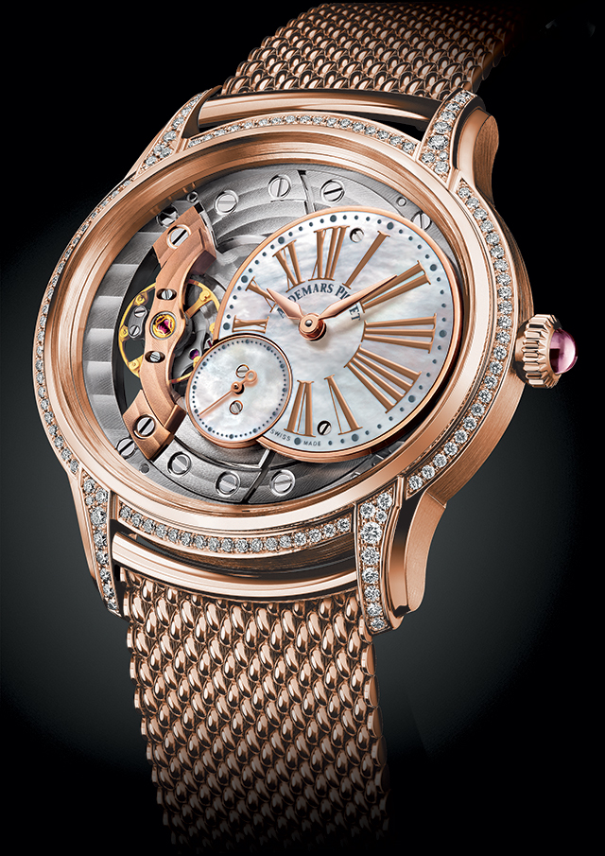Audemars Peguet

Description: Audemars Piguet is synonymous with luxury, innovation, and exceptional craftsmanship, offering a stunning selection of women's watches that blend bold design with high horology. Known for its avant-garde aesthetics and technical mastery, AP timepieces are highly sought after by collectors and fashion-forward women alike.

The most iconic collection for women is the **Royal Oak**, instantly recognizable by its signature octagonal bezel with exposed screws, integrated bracelet, and "Patisserie" patterned dial. Available in stainless steel, rose gold, and diamond-set variations, the Royal Oak combines sportiness with elegance, making it a perfect statement piece. For those who love a more glamorous touch, the **Royal Oak Self-winding and Quartz models** come with diamond-encrusted bezels and luxurious materials, ensuring both style and substance. The **Royal Oak Concept** line takes the design even further, offering futuristic aesthetics and innovative complications like tourbillons and flying skeletonized movements.